Oxford Hackspace
Laser Cutter Manual

Version 1.0
7/12/2016

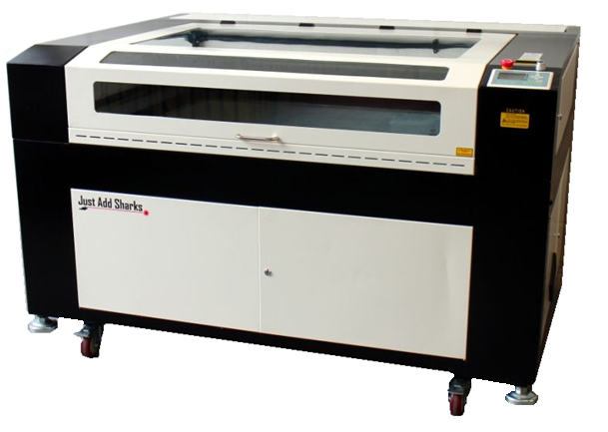



Introduction
The Laser cutter is a fragile piece of equipment.
Humans are also fragile when interacting with dangerous equipment.
as such, guidelines for safe operation are below.
Please note that the laser cutter must NEVER be operated above 65% power .
Knocking the machine can throw the optics out of alignment which will make the machine inoperable until maintenance is performed.
As such a key behaviour when operating or being in the vicinity of the Laser Cutter is to be aware of your actions, operate calmly and smoothly and at a restrained pace to avoid the aforementioned possibility.
Be especially careful when inserting or removing material from the cutter as hitting the cutting head will almost always effect alignment.
The laser cutter has a Perspex window which allows you to view the cutter head as it operates, when viewing it cutting you can see visible light produced when the laser interacts with the medium it is cutting.
Please note that when a bright light is being produced, do not stare at the beam for prolonged periods as bright light could damage your eyes.
However should you watch the light produced from cutting, the likelihood of damage having occurred is minimal as it is primarily visible light, this is simply a caution.
The laser cutter interlock only stops the laser beam from operating with the lid open, the machine will still carry out manoeuvres with the lid open.
Never manually move the head as you risk damaging the machine or effecting the optical alignment.
Try not to leave the machine switched on with the lid open except when performing maintenance (reserved for trained individuals ONLY!) or when setting the bed height.
When going to insert, remove or interact within the machine, press ESC then Datum to home the cutting head.
When cutting any materials, the cutter produces fumes and particulates, these are sucked out of the machine and into the 4 stage filter.
Before starting any operation, make sure the extraction fan is powered on (black plug under the filter must be plugged in to turn on fan).
When finishing any operation, do not open the lid for at least 30 seconds, then ensure the fan remains of for at least 10 minutes after the last job is complete.
As a general guideline:
4mm Acrylic is cut at 65% power, 4% speed
2mm Acrylic is cut at 65% power, 10% speed
4mm Plywood is cut at 65% power, 5% speed
Paper is cut at 18% power, 200% speed

Safety & Permissions

Modifications
You are NOT allowed to perform any modifications or improvements to the machine, should you be found to have modified the machine in any way without permission from a technician, you will be permanently banned from using the machine and fined for damages.

Tasks & Maintenance
You are required to perform some tasks and maintenance when the machine is in use, these include:
Notifying the keyholder that the machine will be in use.
Cleaning the machine of debris before use.
Cleaning the machine of debris after use.
Logging your usage.
Paying for your usage.
Should these tasks not be completed at the time of usage, there my be repercussions as you may have risked damaging property, yourself or others.

Emergency stop
In an emergency, the machine can be shut down immediately by pressing the large red emergency stop button on the front panel. Notify a keyholder if this happens.

Fire
The Laser Cutter has a high risk of fire as such should a fire be sustained by material (the fire is spreading and getting bigger) you need to pause the machine immediately.
Most of the time a fire will quickly burn out and have only travelled a few mm along the material but it if looks to be getting larger, press the emergency button on the cutter, open the lid to the cutter and use the fire blanket to put the fire out.
Should the blanket fail to extinguish the fire, you are to activate the fire alarm by pressing the nearest fire button, if you feel safe to do so use the Co2 Fire extinguisher located to the left of the laser cutter by the chiller and blast the fire with Co2, if it extinguishes slowly sustain a Co2 blast at the smouldering point to ensure the material wont re light when you stop the extinguisher, if the fire does not stop use the powder extinguisher situated outside the room by the fire exit.
There should not be enough material in the cutter to sustain a fire once a power extinguisher has been used.

Ventilation
The ventilation system carries harmful gas and particulates away from the cutter and filters them, it is important the extraction always be operating when the cutter is powered on.
Should the ventilation fail immediately pause the cutter and do not start any cutting then go and contact a keyholder.

Operating Steps
(AT ANY POINT SHOULD THE CUTTER OPERATE OUTSIDE EXPECTED PARAMETERS, HIT THE RED EMERGENCY STOP BUTTON SITUATED NEXT TO THE POWER SWITCH KEY.)
- Place your key fob on the sensor pad, the power will then switch on to the cutter, extractor, air pump and water cooler. (You must leave your fob in place for the cutter to operate, if you remove it from the pad, you have 30 seconds before the power shuts off, should you need to temporarily leave the room, pause the cutter and leave your fob. If you need the toilet, use one of the provided key fobs hanging on the door in the main room)
- Check the air pipe from the 4 stage filter to the cutter is connected.
- Check the chiller unit lights are on and a temperature is being displayed.
- Check that the laser head has homed to the top right corner of the machine.
- Check the blue USB cable from the laser cutter is plugged into the laptop.
- Check the white USB dongle is also plugged into the laptop.
- Insert the material to be cut into the cutting bed.
- Open lasercut 5.3 software. (blue icon on desktop)
- Import your file into Lasercut. (format is .DXF, to import click File in the top left corner, then import.)
- Highlight the entire drawing area by using key command Control + A, select tools then select unite lines and apply. (Generally you can leave the line spacing option at its default value)
- Designate “layers” of you design using colour to give different cuts or engravings.
(highlight all lines you wish to apply a specific cut by holding control and clicking on them then select a colour from the bottom colour menu)
- In the top right corner, select cut type (engrave or cut) and the power (0% - 65%) (repeat this step for all colours in accordance with settings guidelines)
- Download the file to the laser cutter by selecting the button in the bottom left entitled “downLoad”.
- A menu will pop up, select Delete All then select download current. (should the menu not appear when you select “downLoad”, unplug and replug in the blue USB cable and try again, if this does not work, restart lasercut and power cycle the cutter)
- Upon downloading to the laser cutter, go to the laser cutter button pad. (press ESC twice to enable manual control of the cutting head)
- Move the cutting head to the top right of the material being cut and press test.
(when you press test, the cutter will trace the maximum rectangular outline of the object to be cut, if this matches your provided material to cut, proceed)
- Whilst using the bed height alignment tool, press Z to enter bed adjust mode, raise or lower the bed so that the bottom of the lip on the tool touchers the lip of the laser head and the bottom of the tool touches your material. (Insert image of tool held in place over cutting head with arrow markers pointing out relevant points)
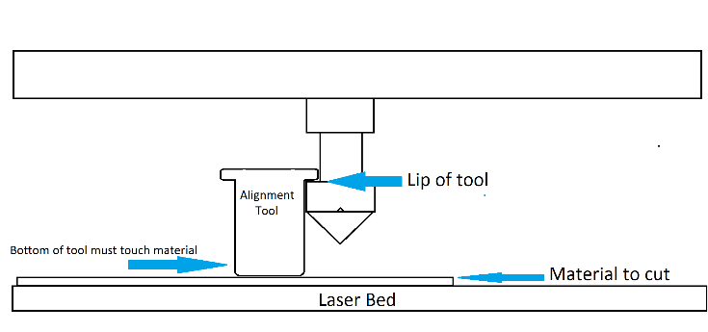
- With the cutter set up correctly, feel the nose of the cutting head to make sure it is clear of debris then close the lid and press start (if there is debris, it should be very easy to remove as it will most likely be carbon dust built up).
- Observe the laser cutter as it runs and ensure the material being cut does not sustain fire (ensure it does not continue to burn when the laser beam has moved on, fire at the point of the cut moving with the cut is a typical occurrence for certain materials and should be allowed to continue).
- Observe the flow of smoke from the cutting head, it should be flowing quickly, pulled to the rear of the machine and should not be building up, if it does build up and does not appear to be flowing stop the machine and check the pipes of the extraction system are still connected throughout the system. Make sure you do not knock the cutter at any point during its cutting process as this may move the material an throw off alignment ruining your work.
- When the machine completes the cut it will beep and move the cutting head back to the start position, at this point carefully lift the lid of the cutter
- Place one hand very smoothly but firmly on the material so as not to move it or the cutting bed and with the other hand gently try pick up a part of the cut material, if you can remove a cut out or you can see the cut went through the whole material and was successful then remove your work otherwise close the lid gently and run the same cut again (if you were careful not to move your work, it should cut over the previous cuts perfectly).
- Pick up any small waste that is produced from the process and has been left on the cutting bed, close the lid of the cutter power it off (turn the key anti clockwise and remove).
- Leave the extractor running for approximately 10 minutes them power it off.
- Fill out the log sheet (It is very important that you fill out the laser cutter log sheet, if you do not log your use right after cutting, you risk a ban from using the cutter)

